EVENT TICKET BOOKING SYSTEM

Full Stack Application Development Project report submitted in partial fulfillment of the requirement for award of the degree of

Bachelor of Technology in
Computer Science and Engineering (Data Science)
 | By
S.VINOTHA | (23UEDC0068) | (VTU24362)
Regulation: 2021 | Semester: WS 25-26 | Year / Batch:  III / 2023
Course Category: PC | Slot:S13+L4 | Course Code:
 |  | 10211DS224
Course Name: Full Stack Application Development


DEPARTMENT OF COMPUTER SCIENCE AND ENGINEERING(DATA SCIENCE)
SCHOOL OF COMPUTING

VEL TECH RANGARAJAN DR. SAGUNTHALA R&D INSTITUTE OF SCIENCE & TECHNOLOGY
(Deemed to be University Estd u/s 3 of UGC Act, 1956) Accredited by NAAC with A++ Grade CHENNAI 600 062, TAMILNADU, INDIA
May, 2026

EVENT TICKET BOOKING SYSTEM

Full Stack Application Development Project report submitted in partial fulfillment of the requirement for award of the degree of
Bachelor of Technology in
Computer Science and Engineering (Data Science)
By

S.VINOTHA | (23UEDC0068) | (VTU24362)
Regulation: 2021 | Semester: WS 25-26 | Year / Batch:
 |  | III / 2023
Course Category: PC | Slot:S13+L4 | Course Code:  10211DS224
Course Name: Full Stack Application Development


DEPARTMENT OF COMPUTER SCIENCE AND ENGINEERING(DATA SCIENCE)
SCHOOL OF COMPUTING

VEL TECH RANGARAJAN DR. SAGUNTHALA R&D INSTITUTE OF SCIENCE & TECHNOLOGY
(Deemed to be University Estd u/s 3 of UGC Act, 1956) Accredited by NAAC with A++ Grade CHENNAI 600 062, TAMILNADU, INDIA
May, 2026

CERTIFICATE

It is certified that the work contained in the project Full Stack Application Development report titled “EVENT TICKET BOOKING SYSTEM” by S.VINOTHA (23UEDC0068) has been carried out in the winter semester of academic year 2025-2026 (WS2526).

Signature of Supervisor Dr.P..Durga Devi Assistant Professor
CSE(DS)
School of Computing
Vel Tech Rangarajan Dr. Sagunthala R&D
Institute of Science and Technology

Signature of Head of the Department
Dr. M.Gokuldhev Professor & Head
CSE(DS)
School of Computing
Vel Tech Rangarajan Dr.Sagunthala R&D
Institute of Science and Technology

DECLARATION

I declare that this written submission represents my ideas in my own words and where others’ ideas or words have been included, I have adequately cited and referenced the original sources. I also declare that I have adhered to all principles of academic honesty and integrity and have not misrepresented or fabricated or falsified any idea/data/fact/source in my submission. I understand that any violation of the above will be cause for disciplinary action by the Institute and can also evoke penal action from the sources which have thus not been properly cited or from whom proper permission has not been taken when needed.

(Signature)
S.VINOTHA
Date: / /

ABSTRACT

The Event Ticket Booking System is a modern developed to simplify and digitize the management of campus events, ticket reservations, and participant engagement through a single, unified platform. Traditional event management methods often depend on manual registrations, paper-based tickets, and scattered communication channels, which can result in delays, errors, and an overall inefficient experience for both organizers and participants. This system addresses these challenges by offering a centralized and automated solution that enables users to easily discover events, explore them based on categories or departments, and book tickets instantly through a clean and user-friendly interface. Once a booking is confirmed, users receive a secure digital pass integrated with QR code verification, ensuring a smooth, fast, and contactless entry process during events. In addition to booking, the system enhances user engagement by providing access to booking history, timely notifications, and downloadable certificates that recognize participation in events. From an administrative standpoint, the platform includes a comprehensive admin portal that allows organizers to efficiently manage event listings, monitor ticket availability, track attendance in real time, and analyze participation trends for better planning. The system incorporates secure authentication and role-based access control to protect user data and ensure that only authorized individuals can access specific functionalities. Features such as automated email and messaging notifications, attendance verification through QR scanning, and streamlined communication further improve operational efficiency. The backend of the application is designed to handle data securely and update information in real time, while the frontend ensures a responsive and visually appealing experience across multiple devices, making the system accessible anytime and anywhere. By integrating essential functionalities such as digital ticketing, automated notifications, and certificate generation, the system becomes scalable enough to support a growing number of events and users without compromising performance. The aim of this project is to improve efficiency, transparency, and accessibility in campus event management by reducing manual effort, minimizing errors, and accelerating processes like registration, attendance tracking, and certification. It also helps institutions maintain well-organized data and gain valuable insights into event participation, enabling informed decision-making for future improvements.
Keywords: Event Management System, Ticket Booking, QR Code Verification, Web Application, Role-Based Access Control, Digital Certification.

LIST OF FIGURES

Figure No. | Description | Page No.
Figure 2.1 | Functional Requirement Diagram | 09
Figure 2.2 | System Architecture Diagram | 13
Figure 3.1 | Sign Up Page | 24
Figure 3.2 | Login Page | 25
Figure 3.3 | Admin Dashboard | 27
Figure 3.4 | Student Dashboard | 30
Figure 4.1 | Data Flow Diagram | 33
Figure 4.2 | Security Architecture Diagram | 37
Figure 7.1 | Plagiarism Report | 53

LIST OF TABLES

Table No. | Description | Page No.
Table 2.1 | User Table in the database | 15
Table 2.2 | Event table in the database | 15
Table 2.3 | Booking table in the database | 16
Table 2.4 | Attendance table in the database | 16
Table 2.5 | Student certificate table in the database | 17
Table 7.1 | Mapping of the project in Complex Engineering Problem (CEP) | 53
Table 7.2 | Mapping of project to Complex Engineering Activities (CEA) | 54
Table 7.3 | SDG Mapping for the Project | 54

LIST OF ACRONYMS AND ABBREVIATIONS

API | Application Programming Interface
HTML | HyperText Markup Language
CRUD | Create, Read, Update, Delete
CSS | Cascading Style Sheets
DBMS | Database Management System
JS | Java Script
HTTP / HTTPS | Hypertext Transfer Protocol / Hypertext Transfer Protocol Secure
IDE | Integrated Development Environment
JWT | JSON Web Token
MVC | Model-View-Controller
PHP | Hypertext Preprocessor
SDLC | Software Development Life Cycle
JSON | JavaScript Object Notation
SQL | Structured Query Language
UAT | User Accepting Testing
MFA | Multi Factor Authentication
XSS | Cross Site Scripting

TABLE OF CONTENTS

Page.No

ABSTRACT iii
LIST OF FIGURES iv
LIST OF TABLES v
LIST OF ACRONYMS AND ABBREVIATIONS vi
- INTRODUCTION 1
  - Introduction 1
  - Background 2
  - Objective 2
  - Problem Statement 3
  - Literature Review 4
- FIRST PHASE WORK 6
  - Software Development Life Cycle (SDLC) 6
  - Requirement Analysis 7
    - Functional Requirements 8
    - Non-Functional Requirements 10
  - Technology Stack Rationale 11
  - System Architectural Design 12
  - Database Schema Design 14
    - Users Table 14
    - Event Table 15
    - Booking Table 15
    - Attendance Table 15
    - Student Certificate Table 17
  - Implementation of Core Artifacts 18
  - Challenges Encountered 19
  - Conclusion of Phase 1 20
- SECOND PHASE WORK 21
  - Introduction to Phase 2 21
  - Enhancement of Security Architecture 22
    - Role-Based Access Control (RBAC) Hardening 23
  - Admin Dashboard 26
  - Administrative Dashboard Enhancements 28
  - Student Dashboard 29
  - Conclusion of Phase 2 31
- SYSTEM ANALYSIS 32
  - System Flow Analysis (Data Flow) 32
  - Structural Analysis (Class Relationships) 34
  - Interaction Analysis (Sequence Logic) 35
  - Security Analysis 36
- IMPLEMENTATION AND TESTING 38
  - Introduction 38
  - System Interface Validation 40
    - Authentication and Access Control 41
  - Limitations and Observed Anomalies 43
  - Error Analysis and Mitigation Strategies 43
  - Summary of Discussion 44
- CONCLUSION AND FUTURE ENHANCEMENTS 46
  - Summary of the Research Study 46
  - Technical and Scientific Contributions 47
  - Critical Evaluation and Limitations 48
  - Strategic Roadmap for Future Enhancements 49
    - Technological Upgrades 51
- ADDRESSING COMPLEX ENGINEERING PROBLEM AND SDG 53
  - Mapping of the Project to Complex Engineering Problem (CEP) 53
  - Mapping of the Project to Complex Engineering Activities (CEA) 54
  - SDG Mapping (CEP Section) 54
REFERENCES 55
Chapter 1

INTRODUCTION

Introduction
The Event Ticket Booking System is a modern web-based platform developed to transform the traditional process of managing campus events into a fully digital and streamlined experience. In many educational institutions, event registration and ticket distribution are still handled manually or through disconnected tools, leading to inefficiencies, data inconsistencies, and poor coordination between organizers and participants. This system addresses these challenges by providing a centralized solution that simplifies event discovery, ticket booking, attendance tracking, and participant engagement within a single platform. Built using full-stack development technologies, the application combines an interactive and user-friendly front end with a robust back end that manages data processing, business logic, and secure storage. It allows users to browse events, filter them by category or department, and reserve tickets instantly, while administrators can create and manage events, monitor bookings, and analyze participation through a dedicated admin portal. Once a booking is confirmed, the system generates a digital pass with QR code verification, enabling a secure and contactless entry process during events. To further enhance usability, the platform provides features such as real-time notifications, booking history, and downloadable participation certificates, improving overall user engagement. Security and data reliability are key aspects of the system, with authentication mechanisms and role-based access control ensuring that only authorized users can access specific functionalities. Proper validation and structured database management techniques are implemented to maintain data accuracy and consistency. The main objective of this system is to improve efficiency, transparency, and accessibility in event management by reducing manual effort and automating key processes such as registration, verification, and certification. By digitizing the entire workflow, the system not only minimizes errors and saves time but also provides a seamless and organized experience for both participants and event organizers, making it highly suitable for modern campus environments.

Background

The rapid growth of educational institutions and the increasing number of campus activities, managing events using traditional methods has become increasingly difficult and inefficient. Earlier, event registrations were handled manually through paper forms or basic digital tools, while ticket distribution and attendance tracking relied heavily on physical processes. These approaches were time-consuming, prone to human errors, and often led to issues such as overbooking, miscommunication, and poor data management. Coordinating between organizers and participants, maintaining accurate records, and ensuring smooth event execution were major challenges. Additionally, the lack of a unified platform made it difficult to track participation, analyze event performance, and provide timely updates to attendees. With advancements in information technology, there is a growing need for a secure, efficient, and automated system that can simplify event management and enhance user experience. The Event Ticket Booking System is developed to address these challenges by providing a centralized digital platform that enables seamless event creation, ticket booking, attendance tracking, and communication. The integration of features such as QR code-based ticket validation, real-time notifications, and digital certification improves accessibility, reduces manual workload, and enhances the overall efficiency and reliability of event management within educational institutions.

Objective

The primary objective of the Event Ticket Booking System is to develop an efficient and reliable platform for managing campus events and ticket bookings in a centralized manner. The system aims to automate key tasks such as event creation, ticket reservation, and attendance tracking.It reduces manual effort and minimizes errors in event management processes. The platform ensures data accuracy, security, and easy accessibility for users.Authentication and role-based access control are implemented for secure usage.It helps administrators monitor bookings and manage event capacity effectively. The system also provides tools to analyze participation and event performance.It is designed to be scalable and flexible for future enhancements . Features like QR-based entry verification improve event security and efficiency.The platform enhances user experience with instant booking confirmation and certificates. Overall, it supports smooth operation, easy maintenance, and long-term usability.

Problem Statement

Managing campus events using traditional or semi-manual methods creates several challenges for educational institutions. Event registration is often handled through paper forms or basic online tools, while ticket distribution and attendance tracking rely on manual processes, leading to inefficiencies and errors. Tasks such as collecting participant details, confirming bookings, issuing tickets, and maintaining records require significant effort and coordination. As the number of events and participants increases, handling large volumes of data becomes difficult, resulting in issues like duplicate bookings, data loss, and lack of proper organization. The absence of a centralized system makes it challenging to coordinate event activities, communicate updates effectively, and ensure a smooth experience for both organizers and participants. Manual methods also increase the chances of errors in tracking attendance and managing event capacity, which can affect overall event planning and execution. Ensuring security and authenticity of tickets is another major concern, as traditional systems lack mechanisms to prevent misuse, duplication, or unauthorized access. Generating participation records, verifying attendance, and issuing certificates require additional time and effort, reducing administrative efficiency. Furthermore, there is limited capability to provide real-time updates, notifications, and seamless interaction between users and organizers, which affects user engagement and satisfaction. The lack of automation in existing event management approaches further complicates operations. Tasks such as managing event listings, monitoring bookings, and analyzing participation trends involve repetitive manual work, increasing the chances of delays and inconsistencies. There is no efficient way to track user activity, generate detailed reports, or gain insights for improving future events. Without a structured digital platform, maintaining data accuracy, avoiding redundancy, and ensuring smooth workflow becomes difficult. Additionally, the absence of a user-friendly interface can make the process confusing and time-consuming for users. These challenges highlight the need for a comprehensive Event Ticket Booking System that can automate event operations, ensure secure and accurate ticket management, improve accessibility, and enhance the overall efficiency and user experience of event management within institutions.
窗体顶端

Literature Review
Advancement of digital technologies has significantly transformed the way events are organized and managed, shifting from traditional manual processes to modern web-based platforms. Researchers have increasingly focused on developing automated event management systems that improve efficiency, accuracy, and user experience. Traditional methods of handling event registrations and ticket distribution are often time-consuming, difficult to manage, and prone to errors, especially when dealing with large numbers of participants. This has led to the adoption of centralized web-based solutions that simplify event booking, tracking, and administration.
Brown and Wilson [1] studied the design and implementation of online event management systems and highlighted that automation reduces manual workload while improving operational efficiency. Their research emphasized that digital platforms enable faster processing of bookings and better coordination between organizers and participants. Kumar [2] analyzed web-based ticket booking systems and found that such platforms provide a structured approach to managing reservations and improving accessibility for users. Chen [3] focused on modern web technologies and demonstrated how they enhance the scalability and responsiveness of event management systems.
He et al. [4] examined user acceptance of online event booking platforms and concluded that ease of use, system reliability, and accessibility play a crucial role in user satisfaction. Unnisa et al. [5] explored secure web-based systems and emphasized the importance of implementing authentication and access control mechanisms to protect user data. Olanrewaju et al. [6] investigated the use of QR code-based attendance tracking and found that it improves verification accuracy and reduces the chances of ticket misuse.
Akhtar et al. [7] studied online ticket reservation systems using full-stack technologies and reported that integrating frontend and backend frameworks enhances system performance and usability. Thakrar and Chavda [8] focused on improving event efficiency through automated ticketing solutions, highlighting the benefits of real-time booking and instant confirmation. Xue and Sun [9] explored data analysis models and demonstrated how participation data can be used to improve future event planning and decision-making.
Recent developments in event management systems include the integration of QR code validation, automated notifications, and digital certification, which enhance both security and user engagement. These features enable contactless entry, real-time updates, and efficient communication between organizers and participants.
From the literature reviewed, it is evident that the combination of modern web technologies, secure data management, and automation plays a crucial role in building efficient event management systems. Based on these concepts, the Event Ticket Booking System is designed to provide a scalable, secure, and user-friendly platform that simplifies event booking, improves administrative efficiency, and enhances the overall experience for both organizers and participants.
窗体底端

Chapter 2

FIRST PHASE WORK

Software Development Life Cycle (SDLC)

The Software Development Life Cycle (SDLC) for the Event Ticket Booking System follows a structured and systematic approach to ensure the development of a reliable, secure, and scalable web application. The process begins with the requirement analysis phase, where the limitations of traditional event management methods are identified and the needs of both event organizers and participants are clearly defined. This includes functional requirements such as event creation, ticket booking, QR-based verification, attendance tracking, and certificate generation, along with non-functional requirements like performance, security, and usability. This is followed by the system design phase, where the overall architecture of the system is planned, including database design, user interface layout, and workflow processes. In the implementation phase, the system is developed using frontend technologies to create an interactive user experience and backend technologies to manage business logic and database operations. This phase also includes the integration of QR code generation and validation features to enable secure and contactless event entry. Once development is completed, the system undergoes thorough testing to ensure that all functionalities work correctly and efficiently. Various testing methods are used to identify and fix errors, ensuring system reliability, performance, and security. After successful testing, the system is deployed in a real-time environment where users can access and utilize its features. The final phase is maintenance, which involves updating the system, fixing bugs, and enhancing features based on user feedback and evolving requirements. Each phase is completed in sequence, ensuring proper planning, execution, and quality control. This structured approach helps in building a robust and efficient Event Ticket Booking System that meets user needs and provides a seamless experience for managing and participating in events.

Requirement Analysis

Requirement analysis is a crucial phase in the development of the Event Ticket Booking System, as it focuses on identifying, analyzing, and documenting the needs of users and stakeholders to ensure the system meets its intended goals. In this phase, a detailed study of traditional event management methods is carried out to understand their limitations, such as manual registration processes, ticket mismanagement, lack of real-time updates, and difficulty in handling large numbers of participants. Based on this analysis, the requirements of the proposed system are clearly defined and categorized into functional and non-functional requirements. Functional requirements include features such as user registration and login, event creation and management by administrators, ticket booking, QR code generation for tickets, attendance tracking, and certificate generation for participants. The system also provides functionalities like booking history, event search and filtering, and real-time notifications to enhance user experience. Non-functional requirements focus on system performance, scalability, security, reliability, and usability, ensuring that the platform can handle multiple users simultaneously while protecting sensitive data through authentication and role-based access control. Additionally, the system must be accessible through a web interface, provide real-time updates, and maintain data consistency and integrity. This phase also involves identifying hardware and software requirements, selecting appropriate technologies, and defining system constraints and assumptions. Proper requirement analysis ensures that the system is developed according to user needs, reduces development risks, and provides a strong foundation for designing and implementing an efficient, secure, and user-friendly event ticket booking platform.

Functional Requirements

The functional requirements for the Event Ticket Booking System focus on automating the complete lifecycle of event management and ticket booking processes. The system must provide secure user authentication and authorization mechanisms to differentiate between participants and administrators. It should include a dynamic event management module that allows administrators to create, update, and manage events, as well as define event details such as date, time, venue, and ticket availability. The system must support user registration and login, enabling participants to browse events, search by category, and book tickets through a user-friendly interface. It should generate digital tickets with QR codes for each booking, allowing secure and contactless entry verification during events. The system must also support real-time booking updates, prevent duplicate reservations, and maintain accurate participant records. On the administrative side, the platform should provide a dashboard to monitor event performance, manage bookings, track attendance, and control event capacity. It should also include features for attendance verification through QR scanning, certificate generation for participants, and sending notifications or updates. Additionally, the system must ensure proper data handling by maintaining structured records and enabling efficient data retrieval. Overall, the Event Ticket Booking System should deliver a seamless, automated, and reliable experience while ensuring accuracy, security, and efficient management of events and participants.

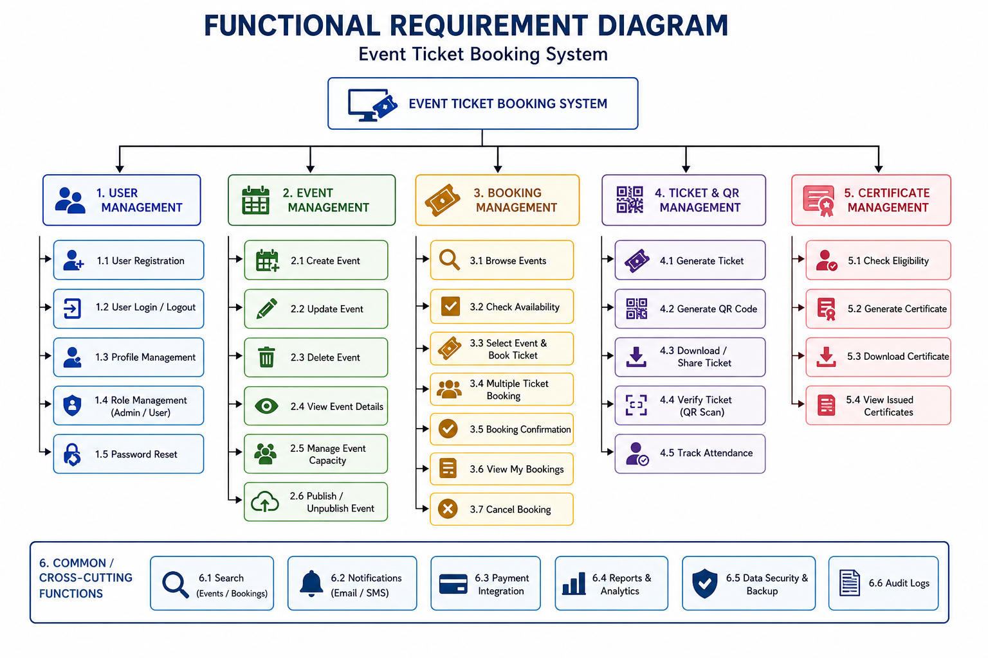

Figure 2.1: Functional Requirement Diagram

Non-Functional Requirements

The non-functional requirements define the quality attributes and operational standards of the Event Ticket Booking System, ensuring its efficiency, reliability, and smooth performance in handling multiple events and users. The system is designed for high performance and responsiveness, enabling quick loading of event details, instant ticket booking, and real-time updates with minimal delay. Scalability is an important aspect, as the platform must support a large number of users and concurrent bookings during peak event times without affecting performance. Reliability is maintained through the use of a structured database system that ensures all data related to events, users, bookings, and attendance is securely stored and consistently retrievable. In terms of usability, the system provides a simple and intuitive interface that allows users to easily browse events, book tickets, and access their information without complexity. The platform is designed for high availability, ensuring users can access it anytime through standard web browsers without interruptions. Maintainability is achieved through a modular system design, allowing developers to easily update features, fix issues, and integrate enhancements such as analytics or feedback systems. Security and data integrity are ensured through authentication and role-based access control, preventing unauthorized access and protecting sensitive user data. Additionally, QR code-based validation ensures secure ticket verification and prevents misuse or duplication. Overall, these non-functional requirements ensure that the system delivers a reliable, efficient, scalable, and secure platform for managing event booking and participation.

Technology Stack Rationale

The selection of the technology stack for the Event Ticket Booking System is based on key factors such as performance, scalability, ease of development, maintainability, and suitability for secure web-based applications. The system uses a well-integrated combination of frontend, backend, database, and supporting technologies to ensure a smooth and efficient event management experience. On the frontend, technologies such as HTML, CSS, and JavaScript are used to design a responsive and interactive user interface that allows users to easily browse events, book tickets, and access their information across different devices. JavaScript plays an important role in handling client-side functionalities such as form validation, dynamic event filtering, real-time updates, and smooth navigation within the platform. On the backend, PHP is used as the primary server-side scripting language to handle application logic, process user requests, and manage communication with the database. It ensures secure session handling, user authentication, and proper control over booking and administrative operations. The database layer is implemented using MySQL, which provides reliable data storage, efficient querying, and strong support for maintaining data integrity. It is used to store user details, event information, booking records, attendance data, and certificates in a structured format, ensuring consistency and accurate retrieval. An important feature of the system is the use of JavaScript for real-time booking updates and dynamic ticket generation, which improves system responsiveness and prevents data loss during the booking process. Additionally, the system incorporates QR code generation and validation to enable secure and contactless event entry. Supporting tools such as Git are used for version control to manage development efficiently, while development environments like Visual Studio Code are used for coding, testing, and debugging. Communication between the client and server is handled through HTTP and HTTPS protocols, ensuring secure data transmission and protection of sensitive user information. Overall, this technology stack provides a reliable, scalable, and secure foundation for developing an efficient Event Ticket Booking System.

System Architectural Design

The Event Ticket Booking System follows a structured multi-layer client-server architecture integrated with a web-based communication model to ensure efficient and secure event management. The architecture consists of the Presentation Layer, Application Layer, Processing Layer, and Data Layer. The Presentation Layer uses HTML, CSS, and JavaScript to provide an interactive and user-friendly interface for both users and administrators, allowing them to browse events, book tickets, and manage activities easily. The Application Layer, powered by PHP, handles core functionalities such as user authentication, event creation and management, ticket booking, notification handling, and certificate generation. The Processing Layer manages key operations like QR code generation and validation, real-time booking updates, and attendance verification to ensure secure and smooth event entry. The Data Layer utilizes a MySQL database to store and manage user information, event details, booking records, attendance data, and certificates in a structured and consistent manner. The system workflow begins when a user interacts with the interface to view or book an event, which is then processed by the backend, validated, and stored in the database. For event entry, the QR code is scanned and verified in real time, updating attendance instantly. The processed information is then returned to the user interface, ensuring a seamless, secure, and synchronized event management experience.

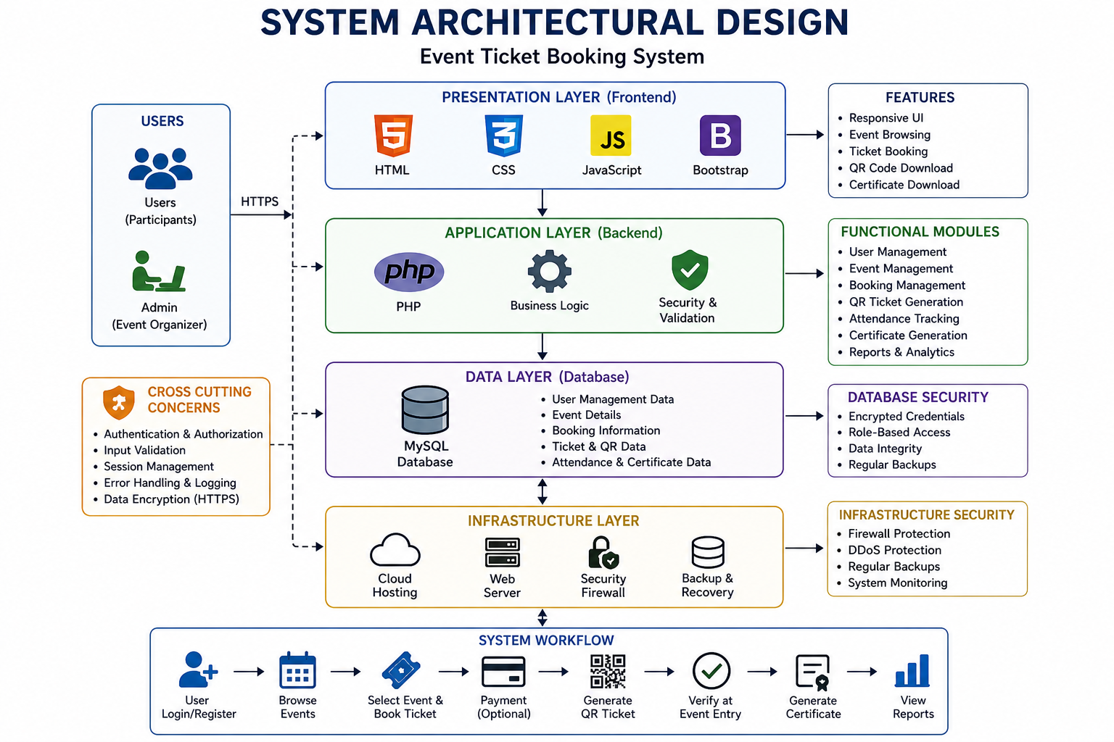

Figure 2.2: System Architecture Diagram

2.5 Database Schema Design
The database schema for the Event Ticket Booking System is designed using a relational database model to ensure efficient storage, retrieval, and management of user and event data while maintaining integrity and consistency. The schema consists of several primary tables namely Users, Events, Bookings, Tickets, and Attendance which together support the core functionalities of the system. This structured design enables smooth interaction between different modules and ensures that data is organized in a logical, scalable, and efficient manner.
The Users table stores detailed information about all individuals in the system including participants and administrators. Each user is uniquely identified by a primary key id and includes attributes such as full name, email, password, role, and basic details. The email field is maintained as unique to prevent duplication and ensure secure authentication. The Events table contains details of all events conducted in the system. Each event is identified by id and includes attributes such as title, description, date, time, venue, capacity, and status. A foreign key created_by links the event to the administrator who created it.
The Bookings table records each reservation made by users and acts as a bridge between Users and Events. It includes attributes such as user_id, event_id, booking status, and timestamps to track booking activity and confirmation. The Tickets table stores information about generated tickets for each booking. Each ticket is uniquely identified and includes attributes such as booking_id and QR code, which is used for secure verification during event entry.
The Attendance table is used to track participant entry into events. It contains attributes such as attendance_id, ticket_id, check-in time, and verification status. This table helps in maintaining accurate attendance records and ensures proper validation of participants during events. The Roles table is used to define different user roles such as admin and participant. It helps in implementing role-based access control in a structured way instead of storing roles directly in the Users table. Each role is identified by role_id and includes attributes such as role name and description, improving flexibility for future enhancements.
The Notifications table is used to store system-generated messages such as booking confirmations, event updates, and reminders. It includes attributes such as notification_id, user_id, message, and timestamp. The Certificates table stores details of certificates issued to participants after attending events, including certificate_id, user_id, event_id, issue date, and certificate link.

2.5.1 Users Table

Field Name | Type | Constraints | Description
id | INT | Primary Key,  Auto Increment | Unique ID for each user
full_name | VARCHAR | Not Null | User full name
email | VARCHAR | Unique, Not  Null | Unique identifier for login
password | VARCHAR | Not Null | Encrypted password
role | ENUM | Default  student | Defines user role
register_number | VARCHAR | Optional | Student academic register number

Table 2.1: Users Table in the database

2.5.2 Event Table

Field Name | Type | Constraints | Description
id | INT | Primary Key, Auto Increment | Unique ID for each event
title | VARCHAR | Not Null | Name of the events
capacity | INT | Not Null | Maximun no. of participate
Time & Date | INT | Not Null | Duration time
venue | ENUM | Default inactive | Event location
created_by | INT | Foreign Key | Reference to admin user

Tables 2.2 : Event table in the database

2.5.3 Booking Table
Field Name | Type | Constraints | Description
id | INT | Primary Key, Auto Increment | Unique ID for booking
qr_code | TEXT | Not Null | QR code for ticket verification
event_id | TEXT | Foreign Key, Not Null | Reference to Events table
status | ENUM | Default confirmed | Booking status
correct_at | DATETIME | Default current time | Booking creation time
Booking_id | INT | Foreign Key, Not Null | Reference to Bookings table

Tables 2.3 : Booking table in the database

2.5.4 Attendance Table

Field Name | Type | Constraints | Description
id | INT | Primary Key, Auto Increment | Unique ID for  Attedence
student_id | INT | Foreign Key, Not Null | Reference to Users table
ticket_id | INT | Foreign Key, Not Null | Reference to Booking table
score | DECIMAL | Default 0.00 | Total score  obtained
status | ENUM | Default pending | Evaluation status
started_at | ENUM | Default not_checked | Attendance verification status

Tables 2.4 : Attendance table in the database

Student certificate Table

Field Name | Type | Constraints | Description
id | INT | Primary Key,  AutoIncrement | Unique ID for certificate
user_id | INT | Foreign Key,  Not Null | Reference to Users table
event_id | INT | Foreign Key,  Not Null | Reference to Event table
issued_date | DATE | Not null | Certificate issue date
file_path | VARCHAR | Not null | Certificate download link
is_correct | TINYINT | Default 0 | Indicates correctness

Tables 2.5 : Student Certificates table in the database

2.6 Implementation of Core Artifacts
The implementation of core artifacts in the Event Ticket Booking System focuses on developing the essential components required for efficient event management, including database entities, backend logic, booking processes, validation mechanisms, and user interface elements. These artifacts form the foundation of the system and ensure that key functionalities such as user authentication, event creation, ticket booking, QR code generation, attendance tracking, and certificate management are executed accurately. The core components are implemented using entity structures, controllers, services, and database interaction modules in the backend, along with responsive frontend interfaces for user interaction. The entity structures represent the database tables such as Users, Events, Bookings, Tickets, Attendance, and Certificates, and are designed using structured development principles. Each entity contains attributes corresponding to database fields, ensuring proper mapping and data consistency. Relationships between entities, such as the connection between users and events through bookings, are maintained using foreign key associations to ensure referential integrity. The backend layer is responsible for handling business logic and system operations. It processes user requests such as registration, login, event browsing, ticket booking, and certificate retrieval while ensuring proper validation and secure data handling. The controller layer manages incoming HTTP requests from the frontend and routes them to appropriate backend functions, enabling smooth communication between the client and server. The system also includes a processing component where QR codes are generated for each ticket and validated during event entry, ensuring secure and contactless verification. The frontend interface is developed using HTML, CSS, and JavaScript, providing an interactive and user-friendly environment where users can explore events, book tickets, and view their activity history, while administrators can manage events and monitor participation efficiently. Input validation techniques are implemented to ensure accurate data entry and improve overall usability. An API-based communication layer is used to connect the frontend and backend using structured data formats such as JSON, ensuring flexibility, scalability, and seamless integration of system components. The database layer is implemented using MySQL, where tables are connected through primary and foreign keys to maintain structured relationships. Efficient querying techniques and indexing are applied to enhance performance and ensure fast data retrieval. Security mechanisms are incorporated through authentication and role-based access control, ensuring that only authorized users can access specific features. Passwords are stored securely using encryption techniques, and input validation helps prevent common security vulnerabilities. The overall architecture follows a modular design approach, ensuring separation of concerns, ease of maintenance, and future scalability. Finally, the system undergoes thorough testing including unit testing, integration testing, and system testing to ensure all components function correctly. The implementation of these core artifacts ensures that the Event Ticket Booking System operates efficiently, securely, and reliably while meeting the requirements of modern digital event management platforms.

2.7 Challenges Encountered in Phase 1
During the initial phase of developing the Event Ticket Booking System, several challenges were encountered, particularly in managing event data and system workflows through a structured approach. One of the major challenges was designing a system that could efficiently handle user data, event details, booking records, and attendance information while ensuring data accuracy and avoiding duplication. Since users and administrators were required to manually input information such as event details and booking data, implementing proper validation mechanisms to prevent incorrect or incomplete entries became essential and required careful planning. Another significant challenge was maintaining relationships between multiple entities such as users, events, bookings, tickets, and attendance. Ensuring that each booking is correctly linked to the respective user and event without inconsistencies posed difficulties during the early stages of development. Integrating these components with the database while maintaining referential integrity and enabling efficient data retrieval added further complexity. Maintaining consistency between different modules such as event management, booking processing, and attendance tracking was also challenging, as updates in one module needed to be accurately reflected across others. Handling edge cases such as duplicate bookings, overbooking beyond capacity limits, invalid inputs, and failed transactions required additional validation logic and error handling mechanisms. Furthermore, implementing QR code generation and validation for secure ticket verification introduced technical challenges, especially in ensuring real-time accuracy and preventing misuse. Ensuring a smooth and user-friendly experience during event booking and entry, along with real-time updates and confirmations without advanced automation, increased the overall complexity of the system design. These challenges required careful planning and structured development to ensure a reliable and efficient event management platform.

2.8 Conclusion of Phase 1
Phase 1 of the Event Ticket Booking System marks the successful completion of the foundational stages of system design and initial development. This phase primarily focused on understanding the problem domain, gathering system requirements, designing the system architecture, and implementing the core functionalities required for a working prototype. The outcomes of this phase provide a strong foundation for further enhancements and the addition of advanced features in subsequent phases. At the beginning of this phase, a detailed analysis of existing event management practices was carried out. It was observed that traditional methods of handling event registrations, ticket distribution, and attendance tracking are mostly manual, time consuming, and prone to errors. Issues such as lack of centralized data management, inefficient communication, and difficulty in maintaining accurate records highlighted the need for a digital and automated solution. Based on these observations, the objectives of the proposed system were clearly defined, focusing on improving efficiency, ensuring accuracy in booking and attendance tracking, and enhancing user experience. The system requirements were carefully identified and categorized into functional and non-functional requirements. Functional requirements included user registration, login authentication, event creation and management, ticket booking, QR code generation, attendance tracking, and certificate generation. Non-functional requirements such as security, scalability, usability, and performance were also considered to ensure reliable system operation and a smooth user experience. Following the requirement analysis, the system architecture was designed using a layered approach to ensure clear separation of components and ease of development. The backend was implemented using server-side technologies to handle business logic, manage user requests, and interact with the database. During this phase, the core modules of the system were successfully implemented. The authentication module was developed to enable secure login functionality and role-based access control. The event management module allows administrators to create, update, and manage events efficiently. The booking module enables users to reserve tickets and receive confirmation instantly. The ticketing module was implemented to generate QR code-based digital tickets for secure entry. The attendance module was developed to track participant entry through QR verification. Additionally, the certificate module was implemented to generate digital certificates for participants after event completion. These implementations ensure that the system can manage events effectively while maintaining accuracy, security, and reliability. Overall, Phase 1 establishes a solid base for further improvements such as advanced analytics, enhanced user engagement features, feedback systems, and additional automation in future phases.

Chapter 3

SECOND PHASE WORK

3.1 Introduction to Phase 2

Phase 2 of the Event Ticket Booking System focuses on the full-scale development, integration, and enhancement of the functionalities that were designed during Phase 1. While the initial phase concentrated on requirement analysis, system design, and prototype planning, this phase transforms those concepts into a fully functional and efficient web-based application. The primary objective of this phase is to automate the complete event management workflow, improve system performance, and ensure seamless interaction between frontend and backend components. This phase plays a crucial role in making the system scalable, secure, reliable, and suitable for real-time usage in managing multiple events and users simultaneously. During this phase, major modules such as User Management, Event Management, Booking Management, Ticket Processing, Attendance Tracking, and Certificate Generation are successfully implemented. The User Management module provides secure registration and login functionalities for both administrators and users, along with role-based access control to ensure proper authorization. The Event Management module enables administrators to create, update, and manage events efficiently. The Booking Management module allows users to reserve tickets, track their bookings, and receive confirmations instantly. The Ticket Processing module generates QR code-based digital tickets, ensuring secure and contactless entry. The Attendance module records participant entry through QR verification, while the Certificate module enables automatic generation of digital certificates after event completion. The system architecture follows a structured Model View Controller (MVC) approach, ensuring separation of concerns and improved maintainability. The backend handles business logic, validation, and database operations, while the frontend provides an intuitive and user-friendly interface for smooth navigation and interaction. Strong validation mechanisms are implemented at both client and server levels to ensure data accuracy and prevent invalid inputs. Security features such as authentication, session management, and encrypted data storage are integrated to protect user information and maintain system integrity. Furthermore, this phase emphasizes performance optimization, real-time processing, and efficient database operations to handle concurrent users without delays. Testing techniques such as unit testing, integration testing, and system testing are conducted to ensure reliability and correctness of the application. Error handling mechanisms are also implemented to manage unexpected scenarios effectively. Overall, Phase 2 ensures that all modules work together seamlessly, resulting in a robust, automated, and efficient Event Ticket Booking System while preparing the platform for future enhancements such as analytics, feedback systems, and advanced reporting features.

3.2 Enhancement of Security Architecture
The enhancement of the security architecture is a critical component of Phase 2 in the development of the Event Ticket Booking System. As the system evolves from a basic prototype into a fully functional platform, ensuring the confidentiality, integrity, and availability of user and event data becomes essential. This phase focuses on strengthening existing security mechanisms and introducing advanced safeguards to protect sensitive information such as user credentials, booking details, and ticket data. One of the major improvements is the implementation of secure authentication mechanisms, where user credentials are validated against encrypted data stored in the database. Passwords are stored using hashing techniques instead of plain text, significantly reducing the risk of unauthorized access and data breaches. In addition, role-based access control is implemented to restrict system functionalities based on user roles, ensuring that administrators can manage events and bookings while users can only access their own tickets and information. Further enhancements include secure session management to maintain user activity safely throughout the system. Features such as session timeout, proper logout handling, and protection against session hijacking are incorporated to prevent misuse of active sessions. Input validation and data sanitization are applied at both client and server levels to prevent common security threats such as SQL injection and cross-site scripting attacks. The system also ensures secure communication between client and server using HTTPS protocols, protecting sensitive data during transmission. Database interactions are handled through parameterized queries and controlled access mechanisms to maintain data integrity and prevent unauthorized modifications.
Additionally, logging and monitoring mechanisms are introduced to track user activities, booking transactions, and system errors, helping administrators detect unusual behavior and respond to potential threats effectively. QR code-based ticket validation is also secured to prevent duplication or misuse of tickets during event entry. Overall, the enhanced security architecture ensures that the system operates in a safe and reliable environment while also supporting future improvements such as multi-factor authentication, advanced monitoring, and stronger data protection techniques.

3.2.1 Role-Based Access Control

The Event Ticket Booking System implements Role-Based Access Control (RBAC) to ensure that users interact with the platform according to their assigned roles and permissions. This approach enhances system security, prevents unauthorized access, and improves usability by clearly separating functionalities between administrators and users. The system is designed with two primary roles, namely Admin and User, each having access to specific features through dedicated dashboards. This controlled access mechanism ensures that sensitive operations such as event creation, ticket management, and attendance tracking are handled only by authorized users, maintaining a secure and well-organized environment. The Admin role is provided with complete control over event management and system operations. Administrators can create, update, and schedule events, define details such as date, time, venue, and capacity, and manage event listings efficiently. They can also monitor bookings, track participant attendance through QR verification, and analyze event performance. Additionally, administrators have the ability to manage user accounts, view booking records, and generate reports related to participation and system usage. This centralized control enables smooth coordination of all event-related activities and ensures efficient system operation. On the other hand, the User role is designed with limited and controlled access to maintain system integrity. Users can securely register and log in, browse available events, and book tickets through an intuitive interface. They can view their booking history, receive confirmations, and access QR code-based tickets for event entry. During events, users can present their QR codes for verification, and after participation, they can receive certificates if applicable. This role-based restriction ensures that users cannot access administrative functionalities such as modifying events or managing other users’ data, thereby maintaining fairness and system security. Overall, the implementation of Role-Based Access Control ensures a secure, efficient, and well-structured system where each user performs tasks according to their defined responsibilities, enhancing both system reliability and user experience.

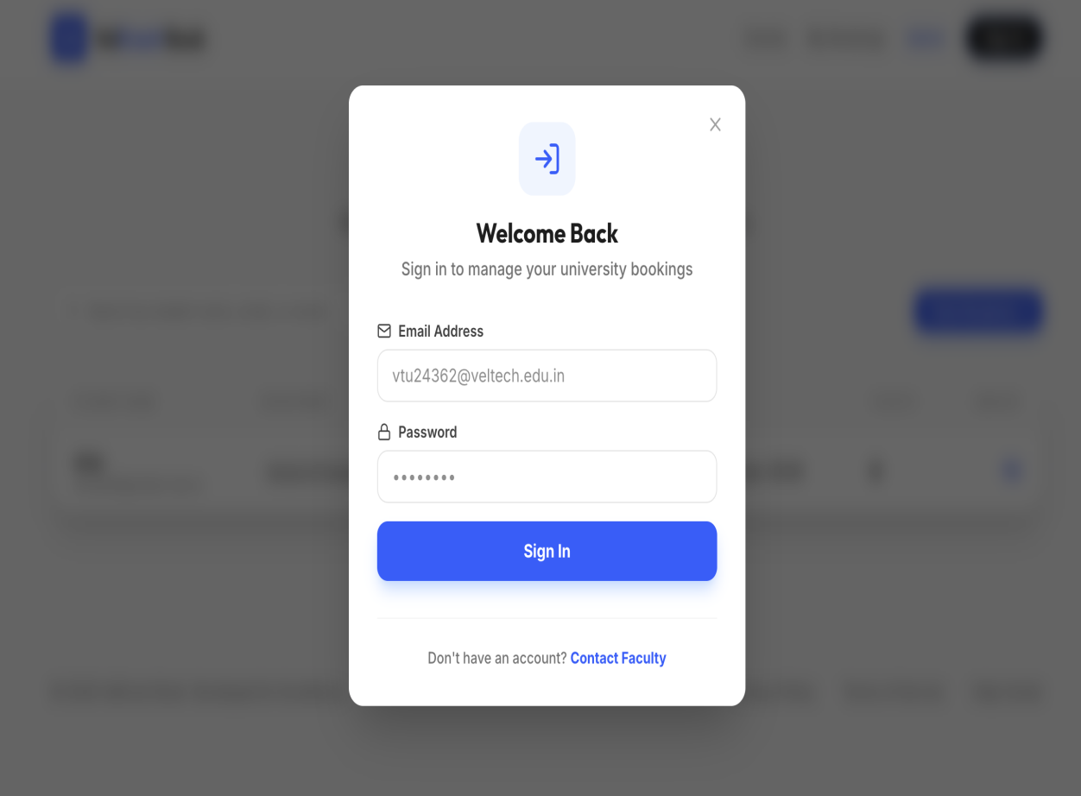

Figure 3.1: Sign up Page

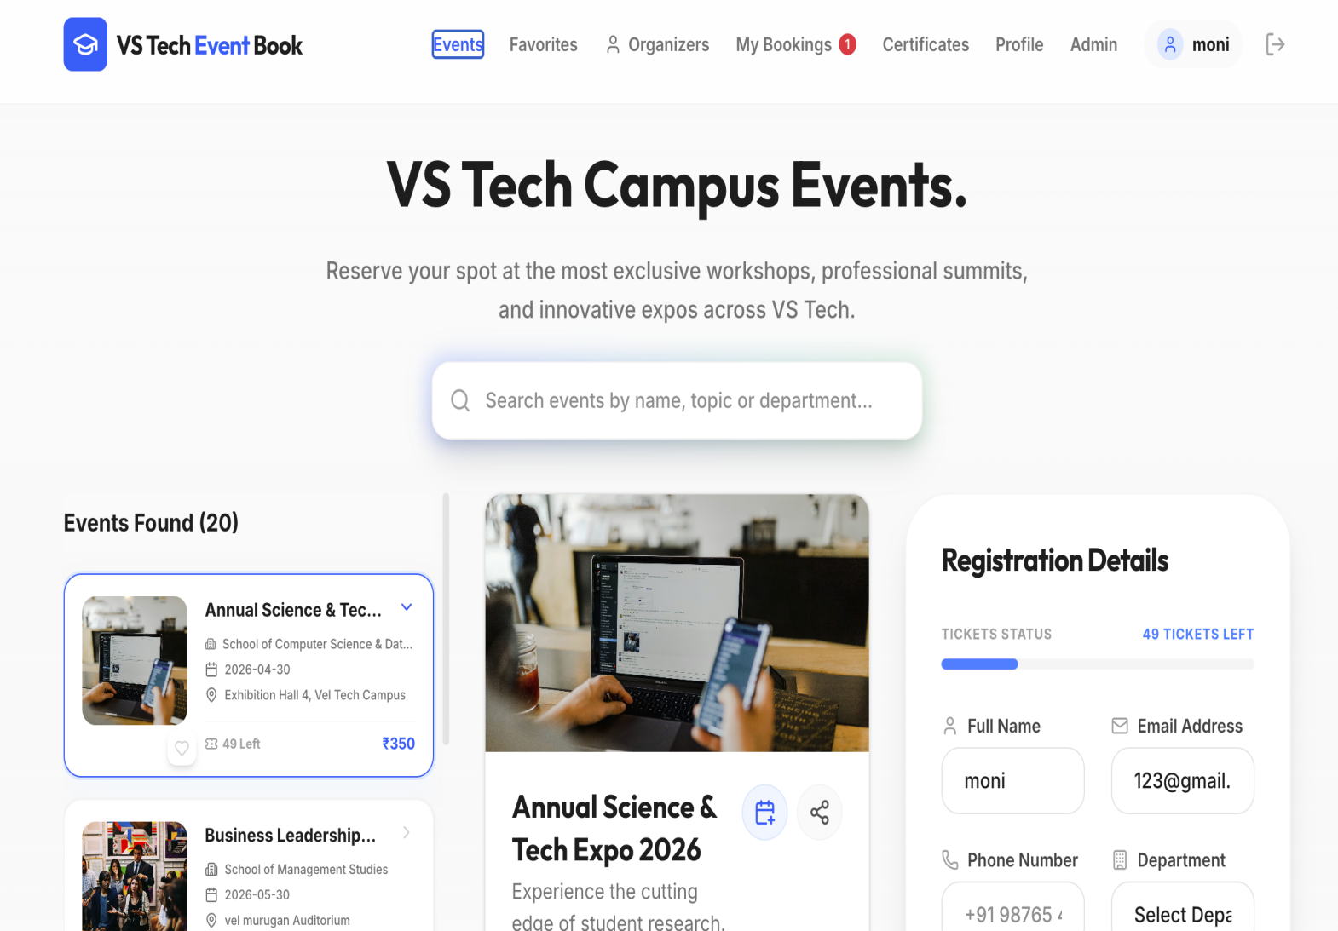

Figure 3.2: Login Page

3.3 Admin Dashboard

The Admin Dashboard is a central component of the Event Ticket Booking System, designed to provide administrators with complete control over event management and system monitoring. It serves as a unified interface through which all administrative tasks can be efficiently performed. Access to the dashboard is restricted through Role-Based Access Control, ensuring that only authorized administrators can perform sensitive operations such as event creation, ticket management, and attendance tracking. One of the primary functionalities of the Admin Dashboard is event management. Administrators can create new events by specifying details such as event title, description, date, time, venue, and capacity. They also have the flexibility to update event details whenever necessary, allowing modifications such as rescheduling or updating event information without affecting the system workflow. Additionally, administrators can delete events that are no longer required, ensuring that the platform remains organized and up to date. The dashboard also provides tools to manage bookings and monitor ticket availability, helping to prevent overbooking and maintain proper event capacity. Another key feature of the Admin Dashboard is monitoring user participation and event performance. Administrators can track the number of users who have registered for an event, view booking records, and monitor attendance through QR code-based verification. The system provides insights into participation trends, helping administrators analyze event success and make informed decisions for future planning. Automated features such as real-time booking updates and attendance tracking reduce manual effort and improve operational efficiency. The Admin Dashboard also supports efficient data organization and retrieval, allowing administrators to quickly access event details, user information, booking records, and attendance data. Security is a critical aspect, and all administrative actions are protected through authentication, authorization, and validation mechanisms to prevent unauthorized access or data manipulation. The interface is designed to be simple and user-friendly, ensuring smooth navigation across different modules. Overall, the Admin Dashboard plays a vital role in managing the entire event lifecycle efficiently while maintaining system reliability, security, and ease of use.

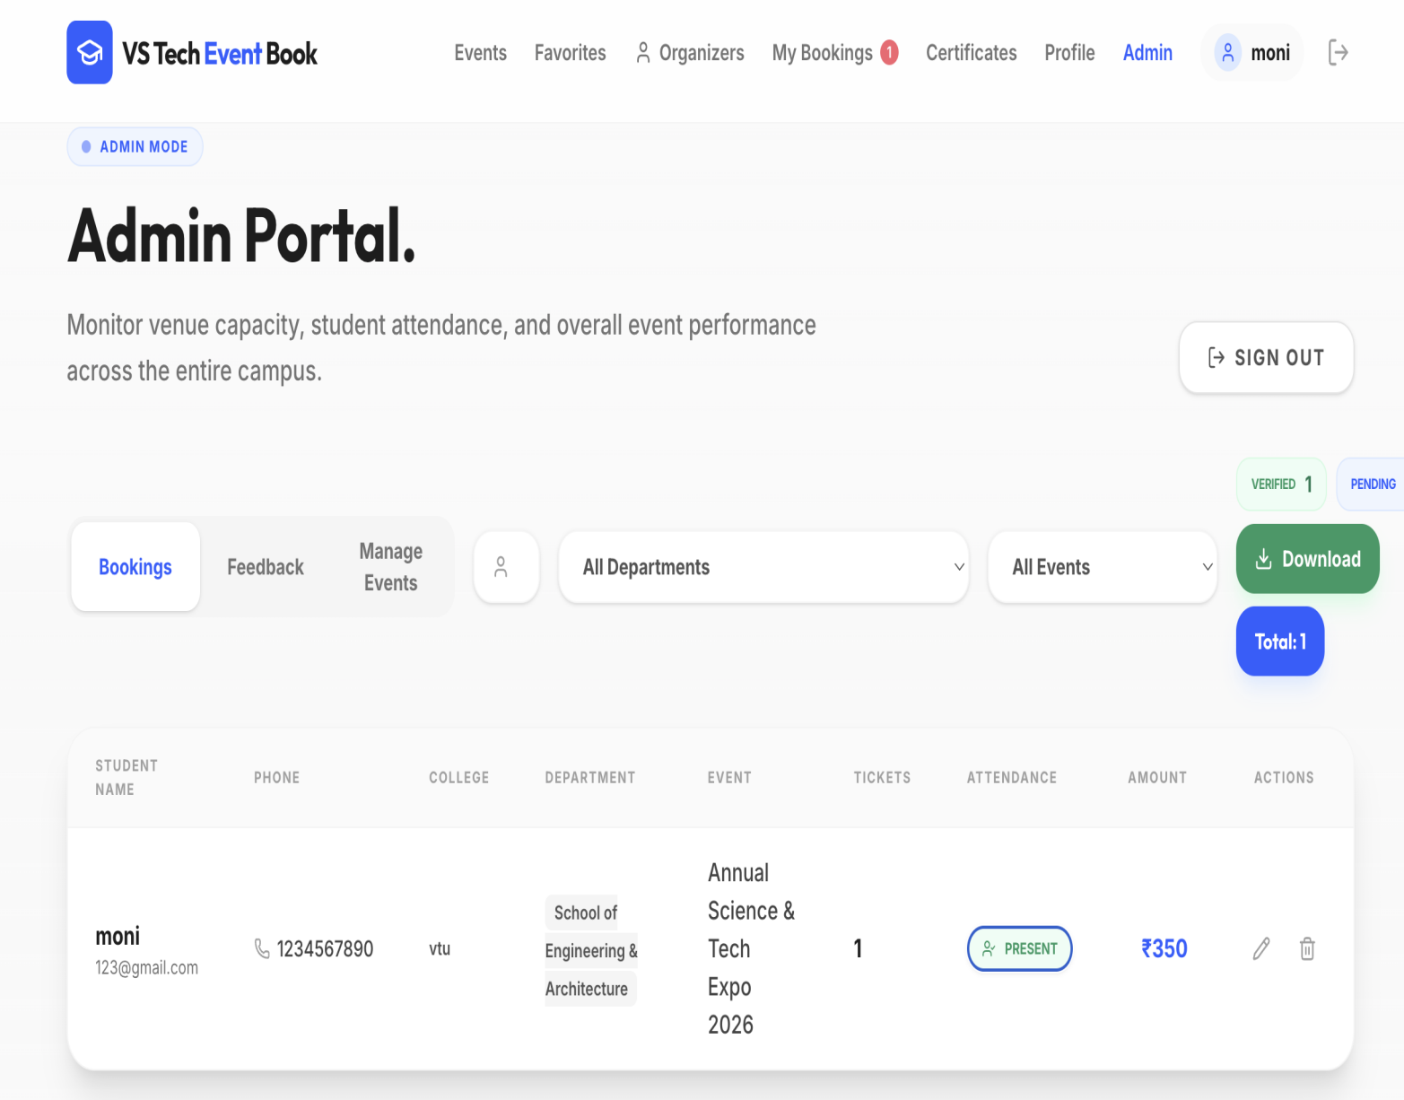

Figure 3.3: Admin Dashboard

3.4 Administrative Dashboard Enhancements

In Phase 2 of the Event Ticket Booking System, several advanced enhancements were introduced to the Admin Dashboard to improve functionality, usability, and overall system intelligence. In addition to basic event management features, the dashboard now includes a visual analytics component that represents event activity over recent days. This feature provides administrators with a clear graphical overview of booking trends, highlighting peak registration periods and helping in better planning and scheduling of future events. Alongside this, a notification banner is integrated into the homepage to display important alerts and system messages such as event announcements, schedule changes, or booking updates, ensuring that both administrators and users stay informed in real time. Another key enhancement is the implementation of automated certificate generation and download functionality. Once a user successfully attends an event, the system generates a digital certificate dynamically based on predefined templates. Administrators can manage certificate issuance, while users can easily download their certificates directly from the platform. This feature reduces manual effort and enhances user satisfaction by providing instant recognition of participation. Additionally, the Admin Dashboard continues to support efficient event management, real-time monitoring of bookings, and structured data presentation, ensuring smooth navigation and control over all system operations. Features such as QR-based attendance tracking, booking status updates, and user activity monitoring further improve administrative efficiency. These enhancements significantly improve the overall usability and effectiveness of the dashboard by combining data visualization, real-time communication, and automated processing features. Security measures such as role-based access control, input validation, and secure data handling are strictly maintained to protect sensitive information and ensure reliable system performance. Overall, the upgraded Admin Dashboard provides a more interactive, informative, and efficient environment for managing events, bookings, and user participation within the Event Ticket Booking System.

3.5 Student Dashboard

The Student Dashboard is a key component of the Event Ticket Booking System, designed to provide users with a simple, intuitive, and efficient interface for exploring and participating in events. Unlike the Admin Dashboard, which focuses on management and control, the User Dashboard emphasizes accessibility, ease of use, and smooth interaction with booking features. It enables users to quickly access relevant information such as available events, booking details, notifications, and participation records without unnecessary complexity. One of the primary features of the User Dashboard is the ability to view and book available events. All active events created by the administrator are displayed in an organized format, including details such as event title, date, time, venue, and availability. Users can easily select an event and book tickets within the available capacity. Once booked, the system generates a QR code-based digital ticket, which can be accessed directly from the dashboard. This ensures a smooth and secure booking experience. Another important functionality is tracking bookings and participation. Users can view their booking history, check ticket details, and confirm their participation in events. After attending an event, users may receive digital certificates, which can be downloaded directly from the dashboard. Additionally, a notification banner is integrated to display important alerts such as event announcements, schedule updates, and booking confirmations, ensuring that users stay informed in real time. The dashboard also focuses on usability and responsiveness, offering a clean and user-friendly interface that works efficiently across different devices. Users can easily navigate between sections such as events, bookings, and certificates without confusion. Security is strictly enforced through Role-Based Access Control, ensuring that users can only access their own data and cannot perform administrative actions. Overall, the User Dashboard provides a seamless, secure, and efficient environment for users to explore events, book tickets, and manage their participation effortlessly.

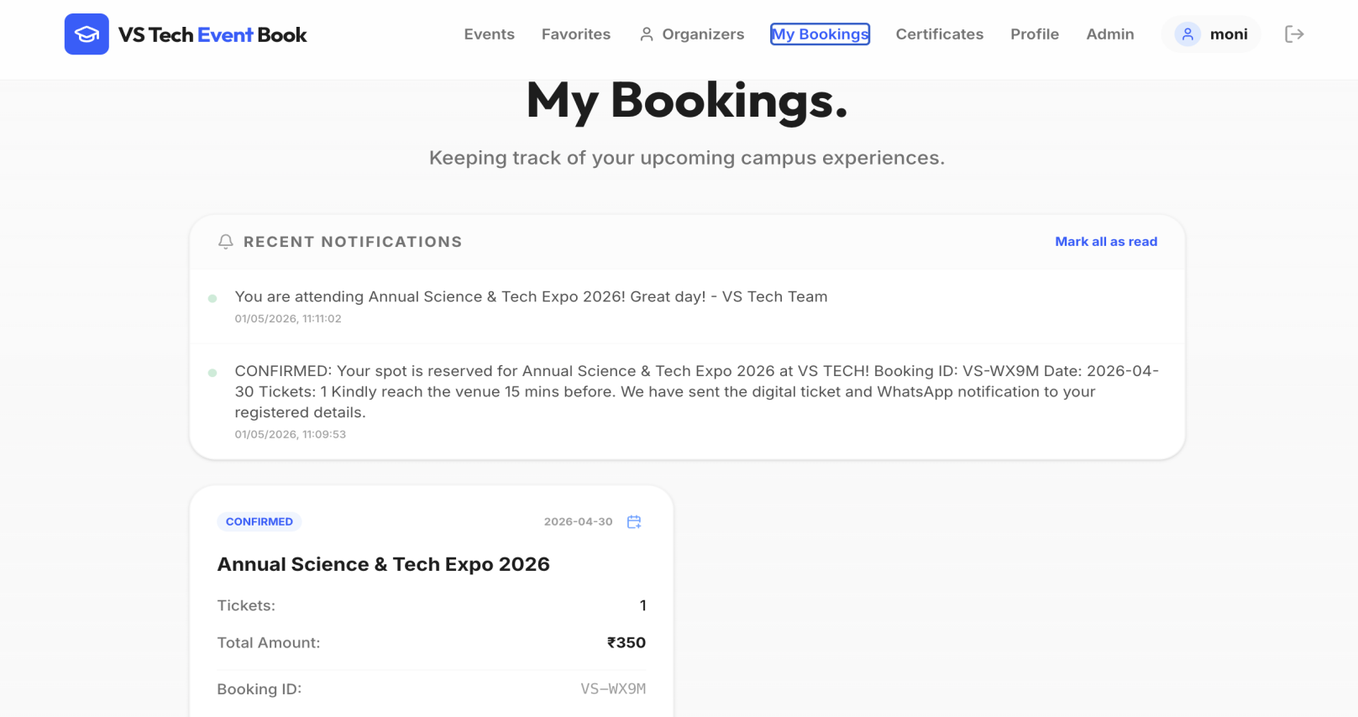

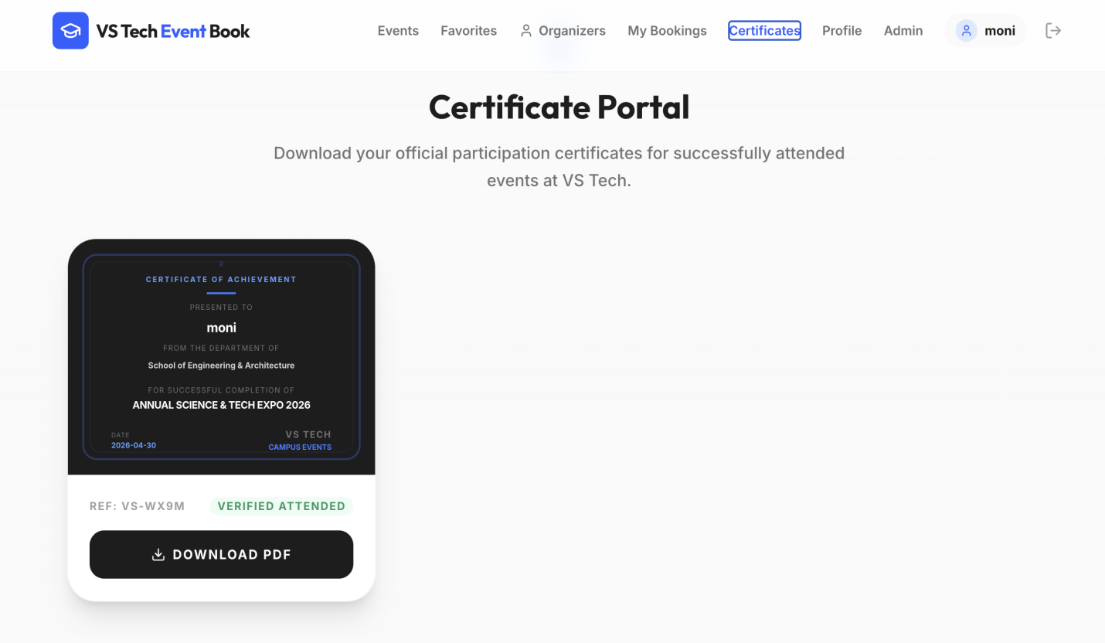

Figure 3.4 Student Dashboard

3.6 Conclusion of Phase 2

Phase 2 of the Event Ticket Booking System marks a significant progression in the overall development of the project, transforming it from a conceptual prototype into a fully functional and integrated application. Building upon the foundation established in Phase 1, this phase focused on implementing core modules, improving system performance, enhancing security, and refining the overall user experience. The successful completion of this phase demonstrates the system’s effectiveness in automating event management processes and providing a reliable platform for organizing and participating in events. Key functionalities such as user authentication, event management, booking handling, ticket generation, attendance tracking, and certificate issuance were successfully developed and integrated. The implementation of Role-Based Access Control ensures that administrators and users have clearly defined permissions, enhancing both system security and usability. The Admin Dashboard has been significantly enhanced to provide comprehensive control over event activities, including creating and managing events, monitoring bookings, tracking attendance through QR verification, and analyzing participation trends using visual insights. Additional improvements such as notification banners for real-time alerts and automated certificate generation further strengthen the system by improving communication and providing instant recognition for participants. Similarly, the User Dashboard is designed to deliver a seamless and user-friendly experience, allowing users to explore available events, book tickets, track their participation, receive notifications, and download certificates. The integration between frontend and backend components ensures smooth data flow, while the use of a structured architecture improves maintainability and scalability. Security enhancements such as password encryption, secure session management, and input validation ensure that the system operates in a safe and reliable environment. Overall, Phase 2 establishes a robust, efficient, and scalable Event Ticket Booking System while also laying a strong foundation for future enhancements such as advanced analytics, mobile optimization, and additional user engagement features.

Chapter 4

SYSTEM ANALYSIS

System Flow Analysis (Data Flow)
The Event Ticket Booking System follows a structured data flow architecture that ensures smooth interaction between users, administrators, system processes, and the database. The system primarily involves two external entities, namely Admin (Event Organizer) and User (Participant), who interact with various processing modules such as authentication, event management, booking management, ticket generation, QR verification, and certificate handling. The data flow begins with the login process, where both admin and users provide their credentials, which are validated against the user database. Once authenticated, the system identifies the user role and grants access to the appropriate functionalities based on role-based access control. From the administrator’s perspective, the data flow focuses on event management and monitoring. Admins can create, update, or delete event details such as event name, category, date, and capacity, which are stored in the event database. They can also monitor bookings, track participation, and manage event-related data efficiently. All updates made by the admin are reflected in real time and made available to users through the system interface.
From the user’s perspective, the data flow revolves around event exploration and ticket booking. When a user browses or searches for events, the system retrieves event details from the database and displays them through the interface. Upon selecting an event, the user initiates a booking request, which is processed and stored in the booking database. After successful booking, the system generates a digital ticket with a QR code, which is linked to the booking record and shared with the user. During event entry, the QR code is scanned, and the system verifies the booking details by retrieving data from the database and updating attendance records in real time. Additionally, after successful participation, the system may generate a digital certificate, which is stored and made available for download by the user. Throughout this process, data flows seamlessly between modules such as authentication, event management, booking processing, and verification systems. Each stage includes proper validation and controlled data handling to maintain accuracy, consistency, and security. This structured data flow ensures efficient system performance, supports multiple users simultaneously, and provides a reliable and user-friendly event booking experience.

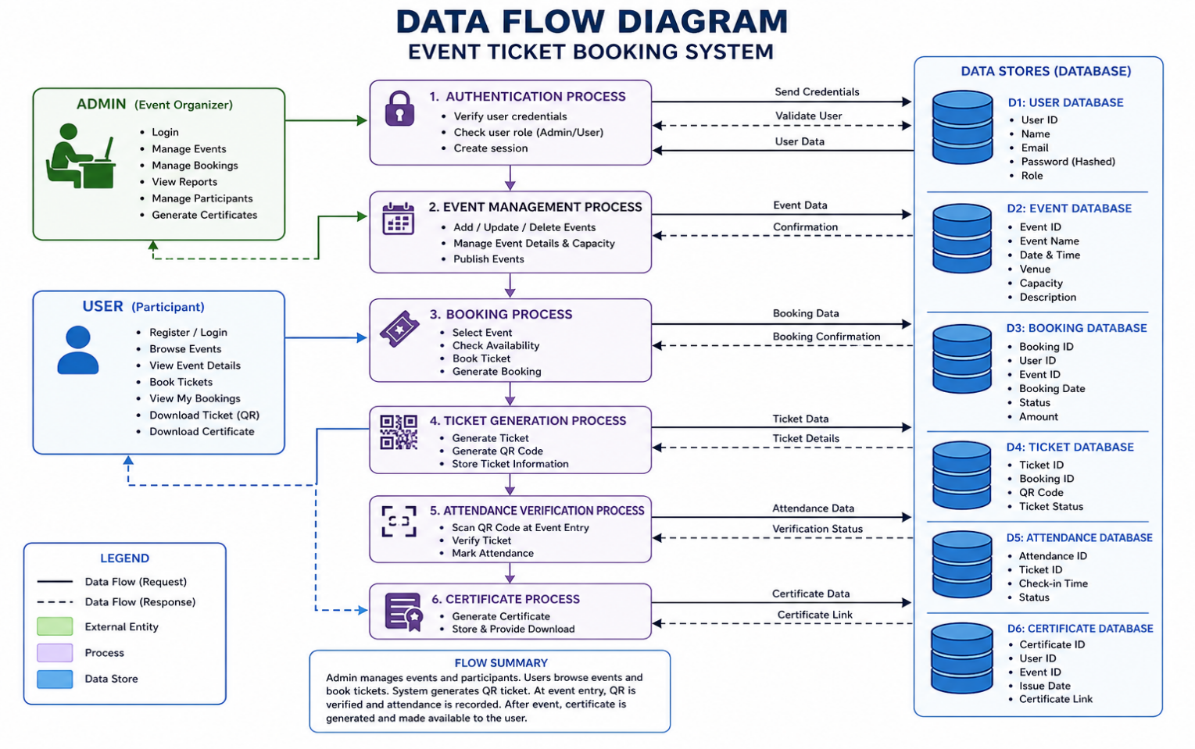
Figure 4.1: Data Flow Diagram

Structural Analysis (Class Relationships)

The structural analysis of the Event Ticket Booking System focuses on identifying the key classes and defining their relationships to ensure efficient data handling and smooth interaction between system components. The design follows an object-oriented approach, where each major functionality is represented as a class. The primary entity classes in the system include User, Event, Booking, Ticket, and Certificate. The User class represents both administrators and participants, containing attributes such as user ID, name, email, password, and role, which determines access privileges within the system. The Event class stores details such as event ID, title, category, date, time, venue, and ticket capacity. The Booking class represents a user’s reservation for a specific event and acts as a linking entity between User and Event. The relationships between these classes are well-structured to support system functionality. A user can book multiple events, and each event can have multiple participants, forming a many-to-many relationship that is resolved through the Booking class. Each booking generates a Ticket, which includes details such as ticket ID, QR code, booking status, and entry validation information. Additionally, after successful participation, a Certificate class is associated with the booking or user, storing certificate ID, issue date, and download link. The relationship between Booking and Ticket is typically one-to-one, while Booking and Certificate may also follow a one-to-one relationship based on event completion.
In addition to these entity classes, the system follows a layered architecture with Controller, Service, and Repository classes. Controllers handle incoming requests such as user login, event creation, ticket booking, and QR verification. Service classes manage business logic including validation, booking processing, QR code generation, and certificate issuance. Repository classes handle database interactions such as storing user data, retrieving event details, managing bookings, and updating attendance records. These layers are interconnected through dependency relationships, ensuring proper separation of concerns, improved maintainability, and scalability. This structured class design enables efficient data flow, accurate booking management, secure ticket validation, and a robust foundation for future enhancements such as analytics, notifications, and advanced event management features.

4.3 Interaction Analysis (Sequence Logic)

The interaction analysis of the Event Ticket Booking System focuses on the dynamic behavior of the system by illustrating how users and administrators interact with different modules such as controllers, services, and repositories. The sequence of operations follows a structured flow where every action is processed through multiple layers to ensure accuracy, security, and efficiency. The interaction begins when a user performs an action through the interface, such as registering, logging in, browsing events, booking tickets, or downloading certificates. The request is first received by the controller layer, which acts as the entry point of the system. The controller then forwards the request to the appropriate service layer, where business logic such as validation, booking processing, QR generation, and decision-making is performed. The service layer communicates with the repository layer to fetch or store data in the database. Once the process is completed, the response flows back through the same layers and is displayed to the user through the interface. For example, during the login process, the user submits credentials through the interface, which are handled by the authentication controller. The controller passes the data to the service layer, where the credentials are validated against the user database. If valid, access is granted and the user is redirected to the dashboard; otherwise, an error message is returned. Similarly, when a user books an event ticket, the request is processed through the booking controller and service, validated, and then stored in the booking database. After successful booking, a QR code is generated and sent back to the user as a digital ticket.
From the administrator’s perspective, interactions include creating events, managing ticket availability, and monitoring participation. When an admin creates or updates an event, the request is processed through the admin controller and service, validated, and then stored in the event database via the repository layer. During event entry, QR code scanning requests are processed to verify user bookings by retrieving stored data and updating attendance records.The overall interaction sequence follows a consistent pattern:User/Admin → Controller → Service → Repository → Database → Repository → Service → Controller → User Interface.
This structured interaction ensures proper separation of concerns, secure data handling, efficient processing, and a scalable system design while providing a smooth and reliable event booking experience.
4.4 Security Analysis
The security analysis of the Event Ticket Booking System focuses on identifying potential risks and implementing robust mechanisms to protect sensitive user data and system operations. Since the system manages important information such as user credentials, booking details, and ticket data, maintaining confidentiality, integrity, and availability is essential. Authentication is one of the core security features, where users are required to log in using valid credentials that are verified against securely stored data in the database. Passwords are protected using hashing techniques, ensuring they are not stored in plain text and significantly reducing the risk of credential theft.
In addition, authorization is enforced through Role-Based Access Control (RBAC), where administrators and users are granted access only to functionalities relevant to their roles. This prevents unauthorized access and restricts critical operations such as event creation, booking management, and attendance tracking to authorized users only. The system also incorporates strong input validation and data sanitization techniques to protect against common threats such as SQL injection and cross-site scripting (XSS). All inputs are validated at both client and server levels to ensure that only valid and safe data is processed and stored.
Secure session management is implemented to maintain user authentication, including session timeouts, proper logout mechanisms, and session invalidation to prevent session hijacking. Data transmitted between the client and server is protected using secure communication protocols such as HTTPS, ensuring that sensitive information cannot be intercepted during transmission. Database security is maintained by restricting direct access and using controlled query mechanisms such as parameterized queries, which help prevent unauthorized data manipulation.
Error handling is designed to display user-friendly messages while logging detailed information internally for monitoring and debugging purposes. Additional protections such as endpoint authorization, request validation, and basic defense against brute-force attacks further strengthen the system. Although advanced features like multi-factor authentication (MFA) and CAPTCHA are not yet implemented, the current layered security approach ensures that the Event Ticket Booking System operates in a secure and reliable environment while providing a strong foundation for future security enhancements.
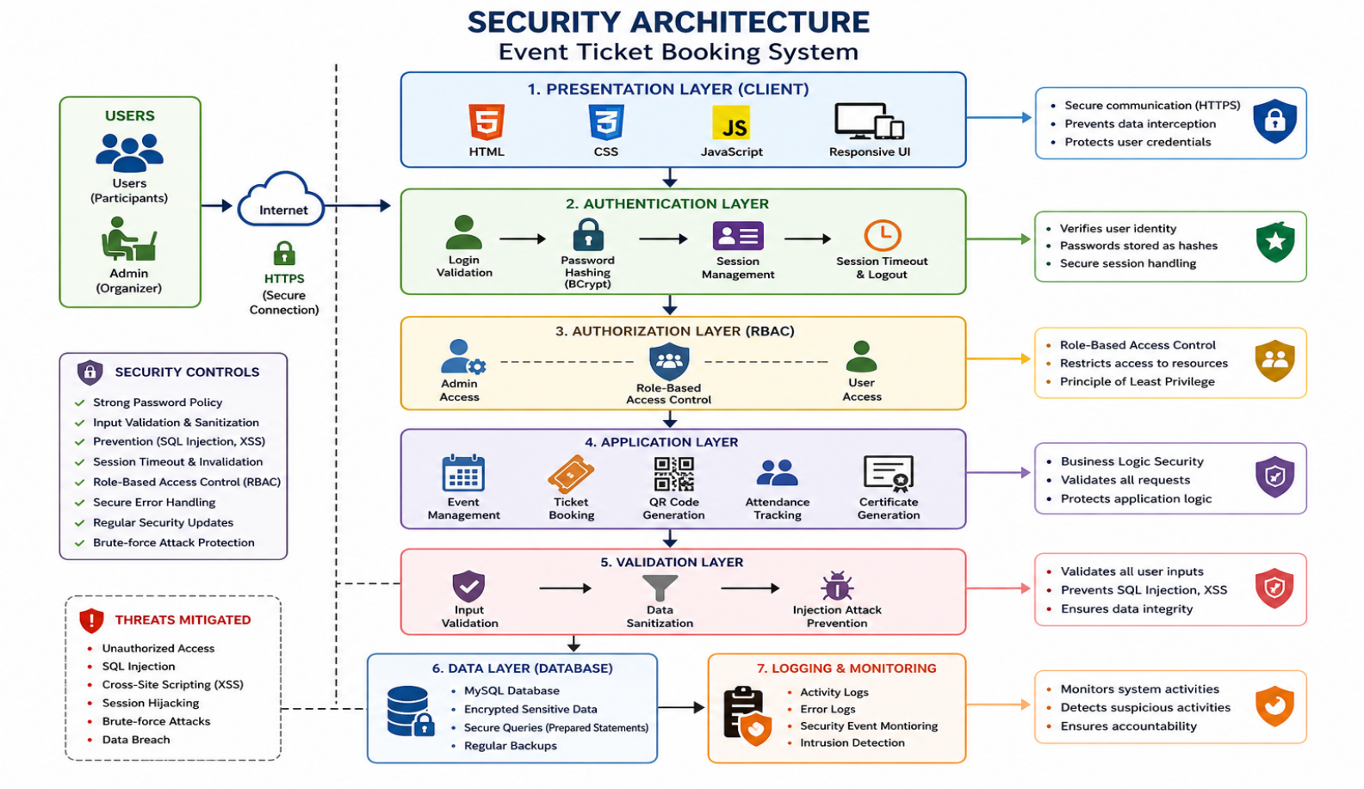

Figure 4.2: Security Architecture Diagram

Chapter 5

IMPLEMENTATION AND TESTING

Introduction

The Implementation and Testing phase of the Event Ticket Booking System is a crucial stage where the designed architecture and planned features are transformed into a fully functional application. This phase focuses on developing the system using a structured layered approach consisting of the presentation layer (HTML, CSS, JavaScript), application layer (backend logic), and data layer (MySQL database). Core functionalities such as user authentication, event management, ticket booking, QR-based ticket generation, attendance tracking, and certificate generation are implemented and integrated to ensure a smooth and reliable event management process. Each module is developed systematically, ensuring proper separation of concerns, maintainability, and scalability of the system.
During implementation, database schemas are created and connected with the backend to enable efficient storage and retrieval of user, event, and booking data. Features such as real-time booking updates, secure session management, and QR code validation are incorporated to enhance system performance and user experience. The testing process plays a vital role in ensuring system reliability and correctness. Unit testing is used to validate individual components, while integration testing ensures proper communication between modules such as events, bookings, and attendance tracking. System testing evaluates the complete workflow, including login, event browsing, ticket booking, and participation verification. Edge cases such as duplicate bookings, invalid inputs, and network interruptions are carefully handled to ensure robustness, security, and accuracy of the system.
Additionally, performance and security testing are conducted to ensure that the system can handle multiple users simultaneously without degradation in speed or accuracy. Load testing evaluates how the system performs under high traffic conditions, especially during peak booking periods, while security testing verifies protection against threats such as unauthorized access, SQL injection, and session hijacking. User Acceptance Testing (UAT) is also carried out to confirm that the system meets user expectations and functions effectively in real-world scenarios. Feedback collected during this stage is used to refine features and improve usability. Overall, this phase ensures that the Event Ticket Booking System is stable, secure, efficient, and ready for deployment in practical environments.

5.2 System Interface Validation

System Interface Validation is an essential part of the implementation and testing phase of the Event Ticket Booking System, ensuring that all user interfaces function correctly and provide a smooth and reliable user experience. The system includes key interfaces such as the login page, admin dashboard, and user booking dashboard. The validation process begins with the login interface, where it is verified that users can successfully log in using valid credentials and are redirected based on their roles. Invalid login attempts are also tested to ensure appropriate error messages are displayed without exposing sensitive information, thereby maintaining both usability and security. For the admin interface, validation ensures that functionalities such as event creation, event updates, booking management, and attendance tracking operate correctly. Input forms are tested to confirm that proper validation rules are enforced, preventing incomplete or incorrect data entries. Navigation across different modules is also verified to ensure that administrators can efficiently manage events, monitor bookings, and track user participation without any issues.
On the user side, the interface is validated to ensure that users can view available events, book tickets without interruption, and access their booking details successfully. Features such as event filtering, ticket generation, and QR code display are carefully tested to ensure accuracy and reliability during the booking and participation process. Additionally, confirmation messages and booking status updates are validated to ensure clarity and consistency. Another important aspect of interface validation is usability and responsiveness. The system is tested to ensure that pages load quickly, respond effectively to user interactions, and provide a clean and intuitive layout across different devices. Error handling mechanisms are also validated to ensure that users receive meaningful feedback in cases such as invalid inputs, session timeouts, or booking failures. Overall, system interface validation ensures that the Event Ticket Booking System delivers a consistent, user-friendly, and error-free interaction experience for both administrators and users.

5.2.1Authentication and Access Control

Authentication and Access Control are critical components of the Event Ticket Booking System, ensuring that only authorized users can access the platform and perform actions based on their assigned roles. The authentication process begins at the login interface, where users enter their credentials such as email and password. These credentials are securely transmitted to the backend and validated against the stored user data in the database. Passwords are protected using strong hashing techniques, ensuring that sensitive information is never stored in plain text. If the credentials are valid, the system authenticates the user and initiates a secure session; otherwise, access is denied with appropriate error messages. Once authenticated, the system enforces access control using Role-Based Access Control (RBAC). Each user is assigned a specific role, such as administrator or user, and permissions are granted accordingly. Administrators have access to functionalities such as event creation, booking management, attendance tracking, and certificate handling, while users are limited to browsing events, booking tickets, and viewing their participation details. This clear separation of roles ensures that sensitive operations are restricted to authorized users only, thereby maintaining system integrity and security.
The system applies access control at multiple levels for enhanced protection. At the interface level, users can only view features relevant to their roles, improving usability and reducing confusion. At the backend level, additional authorization checks are performed before executing any request, preventing unauthorized access even if users attempt to bypass the interface. Secure session management is implemented to maintain user authentication, including session timeout, proper logout handling, and session invalidation to prevent session hijacking. Furthermore, input validation during login and monitoring of repeated failed attempts help protect the system against common threats such as injection attacks and brute-force attempts. These combined mechanisms ensure that the Event Ticket Booking System operates in a secure, reliable, and controlled environment, safeguarding user data and maintaining trust in the platform.

5.3 Limitations and Observed Anomalies
Despite the successful implementation of the Event Ticket Booking System, certain limitations and observed anomalies were identified during development and testing. One of the primary limitations is the basic user interface design. Although the interface is functional and easy to navigate, it lacks advanced responsiveness and modern design elements, which may affect usability across different devices such as mobile phones and tablets. Another limitation is the absence of a real-time notification system. Users do not consistently receive alerts or confirmations for actions such as event updates, booking confirmations, or schedule changes, which may reduce user engagement and awareness. Integrating notification features such as email, SMS, or in-app alerts would significantly improve communication. The system also has scalability constraints in its current form. While it performs efficiently for a moderate number of users, handling a large number of concurrent bookings for popular events may lead to performance issues such as slower response times or temporary delays. During testing, minor anomalies were observed in edge cases, such as delays in booking confirmation during peak traffic or unexpected behavior when invalid inputs are not strictly validated. Additionally, the system currently provides only basic participation data and lacks advanced analytics such as user engagement trends, event popularity analysis, and detailed reporting, which could support better decision-making for administrators. From a security perspective, although core mechanisms such as authentication and session management are implemented, advanced features like multi-factor authentication (MFA), CAPTCHA, and intrusion detection are not yet included. The system also has limited integration with external services such as secure payment gateways, which may restrict its use in paid event scenarios. Furthermore, error handling and user feedback mechanisms can be improved to provide clearer and more informative guidance during failures or system issues. In addition to these limitations, the system currently has limited support for offline handling and recovery mechanisms. In situations such as network interruptions during ticket booking or QR verification, there is a possibility of temporary data inconsistency if proper synchronization is not maintained. Although basic real-time updates are implemented, more advanced fault-tolerant mechanisms such as offline caching and automatic recovery can further enhance reliability.

5.4 Error Analysis and Mitigation Strategies
During the execution of the Event Ticket Booking System, errors may arise from various sources such as user input, system logic, database operations, and network conditions. One of the most common issues is input-related errors, where users may provide incomplete or invalid data, such as incorrect formats or missing required fields while registering or booking tickets. To address this, the system implements strong validation at both the client and server levels, ensuring that only accurate and properly formatted data is processed. Authentication and authorization errors are also carefully managed, where incorrect login credentials or unauthorized access attempts are restricted using secure validation and Role-Based Access Control (RBAC), ensuring that users can only perform actions permitted by their roles. Database-related errors, such as connection failures, query issues, or data inconsistencies, are mitigated using proper transaction management and exception handling techniques. In case of failures during operations like ticket booking or attendance updates, transactions are rolled back to maintain data integrity. Runtime errors, including null values or unexpected logic failures, are handled through structured exception handling, preventing system crashes and ensuring smooth operation. Instead of displaying technical error details, the system provides user-friendly messages while maintaining detailed logs internally for debugging and monitoring.
Concurrency-related issues, such as multiple users booking tickets simultaneously, are addressed through synchronization mechanisms and database constraints to prevent conflicts, overbooking, or duplicate entries. Network and server-related errors, such as slow response times or temporary disconnections during booking or QR verification, are managed through timeout handling, retry mechanisms, and real-time data updates. These strategies help ensure minimal disruption to the booking and event participation process. Additionally, the system incorporates logging and monitoring mechanisms to track errors, user activities, and system performance. These logs assist developers in identifying recurring issues, analyzing system behavior, and implementing necessary improvements. Overall, these mitigation strategies ensure that the Event Ticket Booking System remains stable, secure, and reliable even under high user activity and unexpected conditions.

5.5 Summary of Discussion
The discussion begins with the implementation of the Event Ticket Booking System using a structured, layered architecture. Each component, including controllers, services, database modules, and interface layers, is developed systematically to ensure proper separation of concerns and maintainability. Core functionalities such as user authentication, role-based access control, event creation, ticket booking, QR-based validation, attendance tracking, and certificate generation are effectively implemented, forming the backbone of the application. The integration of these modules ensures seamless communication between different layers, resulting in a cohesive and efficient system. A significant part of this phase focuses on validating system interfaces, ensuring that both the Admin and User dashboards operate correctly and provide a smooth user experience. The Admin Dashboard enables efficient management of events, bookings, and participation monitoring, while the User Dashboard allows individuals to explore events, book tickets, and manage their participation easily. Interface validation confirms that all functionalities are accessible, user-friendly, and responsive across different devices.
The discussion also emphasizes the importance of authentication and access control mechanisms. Secure login processes, role-based permissions, and session management ensure that only authorized users can access specific functionalities. These measures enhance system security, maintain data integrity, and prevent unauthorized actions such as invalid bookings or data manipulation. Testing plays a crucial role in this phase, where unit testing, integration testing, and system testing are conducted to identify and resolve errors. The system is evaluated under various scenarios to ensure reliability, correctness, and consistent performance. Data consistency and integrity are also key considerations. Through proper validation, transaction management, and controlled database interactions, the system ensures that all stored data, including bookings, tickets, and attendance records, remains accurate and reliable. Mechanisms are implemented to prevent duplicate bookings and maintain consistency during critical operations. Transaction management ensures that operations such as ticket booking and attendance updates are either fully completed or safely rolled back in case of failure, maintaining a stable database state.
Performance evaluation is another important aspect discussed in this phase. As the system handles multiple users booking tickets simultaneously, it is essential to maintain optimal response times and system efficiency. Performance testing is conducted under normal and peak conditions, and techniques such as query optimization, efficient data retrieval, and minimizing redundant operations are applied to enhance system speed and responsiveness. These improvements ensure a smooth and uninterrupted experience for both administrators and users. The discussion also highlights scalability and future readiness. Although the current implementation meets core requirements, the system is designed to support future enhancements such as advanced analytics, real-time notifications, payment integration, mobile application support, and cloud deployment. The modular architecture allows these features to be added without major structural changes.
Usability and user experience are given significant importance. The interface is designed to be simple, intuitive, and easy to navigate, enabling users to perform tasks efficiently. Feedback from testing helps identify areas for improvement, such as better layout design, enhanced navigation, and additional interactive features, contributing to a more engaging experience. Finally, the system emphasizes maintainability and ease of development. By following coding standards, modular design principles, and clear separation of responsibilities, the application becomes easier to manage, update, and extend. Overall, the discussion highlights that the Event Ticket Booking System is a well-structured, reliable, and scalable solution, while also identifying areas for future improvement and enhancement.

Chapter 6

CONCLUSION AND FUTURE ENHANCEMENTS
6.1 Summary of the Research Study
The primary objective of this research was to design and develop a web-based Event Ticket Booking System that automates the process of managing events, ticket reservations, and participant engagement efficiently. The system aims to provide a centralized platform where administrators can create and manage events effectively, and users can easily explore events, book tickets, and access participation details. To achieve this, the study focused on implementing key functionalities such as user authentication, role-based access control, event creation and management, ticket booking, QR-based verification, and automated certificate generation. The research methodology followed a structured approach consisting of requirement analysis, system design, implementation, and testing. During the requirement analysis phase, both functional and non-functional requirements were identified to ensure that the system meets user expectations while maintaining performance, security, and usability. The system was then designed using a layered architecture based on the Model-View-Controller (MVC) pattern, which supports modularity, scalability, and ease of maintenance.
In the implementation phase, the system was developed using modern web technologies along with database integration to ensure efficient storage and retrieval of event and booking data. Core modules such as user management, event management, booking processing, and attendance tracking were successfully integrated. Security features including password encryption and role-based access control were incorporated to ensure safe and reliable system operations. The application structure follows a clear separation of concerns through controllers, services, and database layers, enhancing maintainability and flexibility. The testing phase played a crucial role in validating the functionality, performance, and reliability of the system. Various testing methods were applied to identify and resolve issues, ensuring smooth operation under different conditions. Overall, this research demonstrates how a well-designed web-based system can effectively automate event management processes, improve user experience, and provide a scalable and efficient solution for real-world applications.

6.2 Technical and Scientific Contributions
The Event Ticket Booking System demonstrates the effective application of modern software engineering principles, frameworks, and security practices to address real-world challenges in event management. From a technical perspective, the system showcases the implementation of a robust layered architecture based on the Model-View-Controller (MVC) pattern. This architectural approach ensures a clear separation of concerns between the presentation layer, business logic, and data access layer, making the system modular, maintainable, and scalable. It allows future enhancements or modifications to be implemented with minimal impact on existing components. Another significant contribution is the use of a structured backend integrated with efficient database management techniques. The project highlights how backend technologies can simplify application development through organized routing, efficient handling of user requests, and seamless interaction with databases. This demonstrates the practical applicability of modern web technologies in building reliable and production-ready event management platforms.
The system also contributes through the implementation of secure authentication and authorization mechanisms. By incorporating Role-Based Access Control (RBAC), it ensures that access is clearly defined between administrators and users. This not only enhances system security but also provides a practical example of implementing secure login systems, encrypted password storage, and controlled access to functionalities such as event creation, booking management, and attendance tracking. From a data management perspective, the system effectively models relationships between entities such as users, events, bookings, tickets, and attendance records. The use of relational database concepts and structured schema design ensures efficient data storage, retrieval, and consistency. The design of booking and ticket modules reflects strong database principles by managing relationships between users and events in an organized manner.
Scientifically, the project contributes by applying a systematic problem-solving approach through the Software Development Life Cycle, including requirement analysis, system design, implementation, testing, and evaluation. It demonstrates how structured methodologies can be used to develop scalable and efficient systems. Additionally, the project highlights the importance of automation in event management by replacing traditional manual processes with a digital platform, thereby improving efficiency, reducing human errors, ensuring faster processing, and enhancing accessibility. Overall, these contributions present the system as a practical, scalable, and user-centric solution for modern event management needs.
6.3 Critical Evaluation and Limitations
Despite the successful implementation of the Event Ticket Booking System, it has several limitations that affect its overall effectiveness. The system currently lacks advanced features such as detailed analytics, personalized event recommendations, and automated reminders, which are essential for delivering a more engaging and intelligent user experience. Its scalability is also somewhat limited, as it has not been extensively tested under heavy user loads or large-scale simultaneous bookings, which may lead to performance issues in real-world scenarios involving high-demand events. The user interface, while functional, remains basic and not fully optimized for responsiveness across all devices, making it less suitable for mobile users and varying screen sizes.
Although fundamental security mechanisms are implemented, advanced features such as multi-factor authentication (MFA), CAPTCHA, and sophisticated threat detection systems are not yet included, leaving room for further strengthening system security. Additionally, the system does not fully support integration with external services such as payment gateways, SMS alerts, or third-party communication platforms, which limits its real-world applicability. Performance optimization is also minimal, and there may be slight delays in real-time updates, especially during peak booking periods when multiple users access the system simultaneously. Error handling mechanisms can be further improved to provide clearer, more user-friendly feedback during unexpected failures or invalid operations.
Furthermore, the system lacks advanced analytics and reporting capabilities, restricting administrators from gaining deeper insights into user participation trends, booking patterns, and event performance. This limitation affects data-driven decision-making and future event planning. The absence of export features for reports, such as PDF or Excel formats, also reduces its practicality for institutional use. These limitations highlight several opportunities for improvement. Implementing real-time notifications through email or SMS services can enhance communication by informing users about event updates, booking confirmations, and reminders. Introducing advanced analytics dashboards with visual representations can help administrators better understand participation trends and system usage. Additional improvements such as report generation, export functionality, and enhanced performance optimization can significantly increase the system’s efficiency and usability. Addressing these gaps will transform the platform into a more robust, scalable, and user-centric Event Ticket Booking System capable of meeting real-world requirements effectively.

6.4 Strategic Roadmap for Future Enhancements

The Event Ticket Booking System can be further enhanced by focusing on improvements in user experience, functionality, performance, and security. In the short term, upgrading the user interface to a more responsive and modern design and introducing notification features such as email or SMS alerts for event announcements, booking confirmations, and reminders will significantly improve usability and user engagement. Additional features such as automated event reminders, real-time booking status updates, and instant certificate generation after event participation can further enhance the overall experience. To ensure better performance, the system can be optimized and deployed on cloud platforms to efficiently handle a large number of users and concurrent bookings during peak times. Security can be strengthened by implementing multi-factor authentication (MFA), CAPTCHA verification, and token-based authentication mechanisms to protect against unauthorized access and malicious activities. Introducing analytics and reporting dashboards will provide valuable insights for administrators, such as participation trends, booking patterns, and overall system usage, enabling better decision-making and event planning. The system can also be expanded by introducing additional roles such as event coordinators or moderators, along with features like real-time notifications, advanced search and filtering options, and personalized event recommendations based on user interests.
Further improvements may include implementing backup and recovery mechanisms to ensure data safety, as well as API integration to connect with external services such as email systems, payment gateways, or institutional platforms. Enhancing accessibility through multilingual support and user-friendly design for differently-abled users will make the system more inclusive. Features such as feedback collection after events, performance monitoring tools, and detailed logging systems can help in evaluating system effectiveness and maintaining system health. The platform can also include event categorization, calendar synchronization, and reminder scheduling for better planning and organization. Additionally, incorporating progressive web application capabilities or offline access features can improve usability in low-network conditions. In the long term, developing a dedicated mobile application and integrating with external platforms will further enhance accessibility and functionality, making the system more robust and suitable for real-world deployment. These enhancements provide a clear roadmap for transforming the Event Ticket Booking System into a more advanced, scalable, and user-centric platform.

6.4.1 Technological Upgrades

The Event Ticket Booking System can be significantly enhanced through various technological upgrades that improve performance, scalability, security, and overall user experience. As technology continues to evolve, adopting modern tools and frameworks will ensure that the system remains efficient and aligned with current industry standards. One of the key upgrades is the adoption of modern frontend technologies such as React, Angular, or Vue.js, which can provide a more dynamic, responsive, and interactive user interface. This will improve usability for users booking tickets and administrators managing events across different devices and screen sizes. Implementing responsive design techniques will further ensure smooth accessibility on mobile devices and tablets.
On the backend, upgrading to advanced architectural approaches such as microservices can greatly improve scalability and maintainability. Instead of a monolithic structure, the system can be divided into independent services such as user management, event management, booking processing, and notification handling. This approach allows easier scaling, faster deployment, and better fault isolation. Another important upgrade is the use of cloud computing platforms such as AWS, Azure, or Google Cloud. Deploying the application on the cloud ensures high availability, better scalability, and improved performance, especially during peak booking times when many users access the system simultaneously. Cloud services also provide features like automated backups, load balancing, and system monitoring.
The system can further benefit from database optimization and modernization. Incorporating caching mechanisms such as Redis can significantly improve data retrieval speed and reduce system load. Additionally, indexing and query optimization techniques can enhance performance when handling large volumes of booking and event data. In terms of security, implementing advanced measures such as multi-factor authentication (MFA) and token-based authentication like JSON Web Tokens (JWT) can provide stronger protection for user accounts and sensitive data.
Another important enhancement is the integration of real-time communication technologies such as WebSockets, which enable instant updates for booking confirmations, ticket status, and notifications without requiring page refreshes. The system can also incorporate API development using RESTful or GraphQL services, allowing seamless integration with external services such as email notifications, SMS gateways, and third-party platforms. Overall, these technological upgrades will make the Event Ticket Booking System more scalable, secure, efficient, and future-ready.

Chapter 7

ADDRESSING COMPLEX

ENGINEERING PROBLEM AND SDG

7.1 Mapping of the Project to Complex Engineering Problem (CEP)

Level | Attribute |  | Characteristics | WKs |  | Justification
WP1 | Depth of edge | Knowl- | Requires in-depth engi-neering knowledge | WK3, WK4, WK5, WK6 |  | Requires knowledge in Flask, databases, cybersecurity (OTP, SHA256), and AI mod-els (LLM, CNN) for building a secure phar-  macy system.
WP2 | Conflicting quirements | Re- | Technical and non-technical conflicts | WK4, WK6 | WK5, | Balances security and usability, ensuring  fast transactions with secure OTP authenti-cation and reliable AI outputs.
WP3 | Depth of Analysis |  | Analytical and design thinking | WK3, WK5 | WK4, | Involves algorithm selection, system de-sign, and integration of AI with real-time pharmacy operations.
WP4 | Familiarity |  | Partially new problems | WK4, WK8 |  | AI chatbot integration with pharmacy work-flows introduces modern challenges beyond  traditional systems.
WP5 | Applicable Codes |  | Limited standard solu-tions | WK6 |  | Requires custom design for integrating AI  and OTP-based loyalty security not covered in existing systems.
WP6 | Stakeholder Needs |  | Multiple stakeholders in-volved | WK5, WK7 | WK6, | Handles requirements of staff, customers, and admins ensuring secure and efficient in-teractions.
WP7 | Interdependence |  | System-level integration | WK3, WK6 | WK5, | Integrates frontend, backend, database, AI modules, and security layers into one sys-  tem.
Table 7.1: Mapping of Project to Complex Engineering Problem (CEP)

7.2 Mapping of the Project to Complex Engineering Activities (CEA)

EA No. | Attribute | Characteristics | Justification based on the Project
EA1 | Range of Resources | Use of diverse technologies | The project uses Flask, SQLite, AI models (LLM, CNN), OTP APIs, and frontend tech-nologies for full system development.
EA2 | Level of Interactions | Complex interactions be-tween modules | The system manages interactions between billing, loyalty system, AI chatbot, and secu-rity layers efficiently.
EA3 | Innovation | Application of modern tech-nologies | Integration of AI chatbot, image-based recog-nition, and OTP-secured transactions demon-strates innovation.
EA4 | Consequences to So-ciety and Environ-ment | Impact on users and society | Improves healthcare accessibility, ensures se-cure transactions, and reduces errors in phar-macy operations.
EA5 | Familiarity | Beyond standard practices | Combines AI, security, and pharmacy manage-ment into a unified system, going beyond tra-ditional solutions.
Table 7.2: Mapping of Project to Complex Engineering Activities (CEA)

7.3 SDG Mapping (CEP Section)

SDG No. | SDG Title | Relevance to the Project
SDG 3 | Good Health and Well-being | Provides AI-based healthcare assistance and improves access to medicine recommendations.
SDG 9 | Industry, Innovation and In-frastructure | Promotes digital transformation in pharmacy systems using AI and secure technologies.
SDG 16 | Peace, Justice and Strong In-stitutions | Ensures secure transactions and data protection through OTP au-thentication and encryption.
SDG 12 | Responsible Consumption and Production | Improves pharmacy efficiency and reduces errors in medicine handling and transactions.
Table 7.3: SDG Mapping for the Project

References

[1] Brown, T., & Wilson, J. (2024). Design and Implementation of an Online Event Management System. Journal of Web Engineering.
[2] Kumar, R. (2024). Web-Based Ticket Booking System for Event Management. SSRN Electronic Journal.
[3] Chen, Q. (2024). Development of Smart Event Management Systems Using Modern Web Technologies. Applied Computing and Informatics.
[4] He, X., Liao, Z., Zhou, F., Zhang, Y., & Yang, J. (2025). User Acceptance of Online Event Booking Platforms in Smart Campus Environments. Frontiers in Computer Science.
[5] Unnisa, I., Baseer, S., & Mohammed, A. B. (2025). Secure Web-Based Ticket Booking and Event Management System. International Journal of Information Technology.
[6] Olanrewaju, T. O., Isiaka, R. M., & Babatunde, S. R. (2025). Enhanced Event Management System with QR Code-Based Attendance Tracking.
[7] Akhtar, M. T., Arafat, K., & Sohel, M. A. (2025). Online Ticket Reservation System Using Full Stack Technologies. International Journal of Computer Sciences and Engineering.
[8] Thakrar, A., & Chavda, P. (2025). Improving Event Efficiency Through Automated Ticketing Systems. International Journal of Scientific Innovation Engineering.
[9] Xue, M., & Sun, D. (2025). Data Analysis Model for Event Participation and User Engagement. Discover Computing.
[10] Mozilla Developer Network. (2024). HTML, CSS, and JavaScript Guide. Retrieved from https://developer.mozilla.org/
[11] W3Schools. (2024). Web Development Tutorials. Retrieved from https://www.w3schools.com/
[12] Github link:https://github.com/vinothaofficial12/Event Ticket Booking System .

